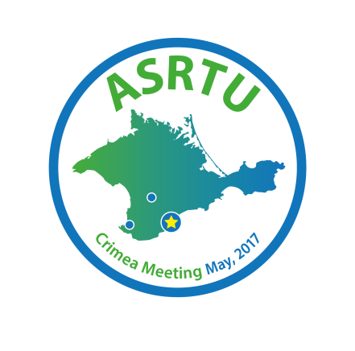
ASRTU FORUM IN THE CRIMEA (“ALUSHTA-2017”)
7–13 May 2017
Crimea, Russia

Registration Form
Last/Family/Surname: First/Given Name：
Organization:

Job Title:
Address:
Phone: Mobile:

E-mail: FAX:

Emergency Contact name and phone:

Dates of stay in Ekaterinburg (please mark):
□ 7 May □8 May □9 May □10 May □11 May □12 May □13 May

VISA REQUIREMENTS

If you need a visa to the Russian Federation, please enter the following info:
Full name (as it is written in your passport):
Nationality:
Place of birth (country/city):
Date of birth (mm/dd/yy):
Gender: □ Male □ Female
Passport:
Period of stay in Russia (mm/dd/yy): from to
Place of applying for a visa (country, city):
Permanent residence (address):

Please note: to enter the Russian Federation your passport must be valid at list 6 months after your planned date of departure from Russia.
Please send the filled registration form and the copy of your passport before 17th of March 2017
to organizing committee e-mail: asrtu_crimea2017@163.com

